

**MASINDE MULIRO UNIVERSITY OF SCIENCE AND TECHNOLOGY**

**SCHOOL OF COMPUTING AND INFORMATICS**

**DEPARTMENT OF COMPUTER SCIENCE**

**PLANTEX**

**(APPLICATION OF CONVOLUTIONAL NEURAL NETWORKS TO THE CLASSIFICATION AND DIAGNOSIS OF MAIZE DISEASES AND INFERENCE PERFORMANCE ON ANDROID)**

Submitted by:

NAME: ODERA DICKENS OCHIENG

REG NO: COM/B/01-02204/2016

COURSE CODE: BCS 417

COURSE TITLE: COMPUTER SCIENCE PROJECT 2

A project report submitted in partial fulfillment of the requirement for the award of the degree of Bachelor of Science in Computer Science of Masinde Muliro University of Science and Technology.

June 2020

**DECLARATION AND CERTIFICATION**

**DECLARATION**

I, Odera Dickens Ochieng, hereby declare that this is my original piece of work that has not been submitted before any other panel for the purpose of fulfilling the requirement for the award of any bachelor’s degree neither in Masinde Muliro University of Science and Technology nor any other institution of higher learning in the Republic of Kenya or around the world.

Signature: …………………………………….. Date ……June 27, 2020……………

Odera Dickens Ochieng

COM/B/01-02204/2016

[odickens@student.mmust.ac.ke](mailto:odickens@student.mmust.ac.ke)

**CERTIFICATION**

The undersigned do hereby certify that they have supervised and coordinated this work entitled “APPLICATION OF CONVOLUTIONAL NEURAL NETWORKS TO THE CLASSIFICATION AND DIAGNOSIS OF MAIZE DISEASES AND INFERENCE PERFORMANCE ON ANDROID” and hereby recommend for acceptance of Masinde Muliro University of Science and Technology project report.

Signature: ………………………… Date: …………………………

Dr. Raphael Angulu (PhD)

Senior Lecturer

School of Computing and Informatics

Department of Computer Science

Masinde Muliro University of Science and Technology

Signature: ………………………… Date: …………………………

Dr. Jasper Ondulo (PhD)

Projects Coordinator

School of Computing and Informatics

Masinde Muliro University of Science and Technology

**ACKNOWLEDGEMENT**

First and foremost, I want to thank the Almighty God for the abundance of good health, knowledge, knowledge, wisdom, protection, and peace that He accorded me throughout the development of this project.

I would like to express my sincere gratitude to the projects coordinator, department of Computer Science, Dr. Jasper Ondulo, for his leadership in making sure that I, as a BSc Computer Science student, get to think of and develop solutions for the problems that we face as a society.

I would also want to extend my sincere gratitude to Dr.Raphael Angulu and Mr. Charles, for their guidance and support in helping me understand the concept of Convolutional Neural Networks that form the basis of this project.

I would also like to thank the dean, cod and all the staff at the school of computing and informatics for instilling knowledge and professionalism in me that have helped me throughout the development of the project.

Lastly, but not least, let me also acknowledge the efforts by my family, classmates and fellow colleagues at the school of computing and informatics and Masinde Muliro University at large, for the continued supports before and throughout the development of this project.

**ABSTRACT**

Plant leaf diseases can affect plant leaves to a certain extent that the plants can collapse and die completely. These diseases may drastically decrease the supply of vegetables and fruits to the market, and result in a low agricultural economy. In the literature, different laboratory methods of plant leaf disease detection have been used. These methods were time consuming and could not cover large areas for the detection of leaf diseases. This study infiltrates through the facilitated principles of the convolutional neural network (CNN) in order to model a network for image recognition and classification of these diseases.

An android smart phone was used to perform the training of a CNN network that recognized and classified images of the maize leaf diseases that were collected by use of the camera. A novel way of training and methodology was used to expedite a quick and easy implementation of the system in practice. The developed model was able to recognize four different types of maize leaf diseases out of healthy leaves. The northern corn leaf blight (*Exserohilum*), common rust (*Puccinia sorghi*), gray leaf spot (*Cercospora*) and Maize Streak Virus diseases were chosen for this study.

Contents

2 1. CHAPTER ONE: INTRODUCTION vi

3 2. CHAPTER TWO: LITERATURE REVIEW xii

4 3. CHAPTER THREE: METHODOLODY xx

5 4. CHAPTER FOUR: SYSTEM DESIGN xxvi

6 5.0 CHAPTER FIVE: SYSTEM IMPLEMENTATION xxvii

7 6. CHAPTER SIX: DISCUSSION xliv

8 7. CHAPTER SEVEN: SUMMARY, CONCLUSIONS AND RECOMMENDATIONS xliv

9 8. REFERENCES xliv

10 9. APPENDICES xlvi

# 1. CHAPTER ONE: INTRODUCTION

* 1. **Background Information**

Plant health and food safety are closely linked. The Food and Agriculture Organization of theUnited Nations (FAO) estimates that pests and diseases lead to the loss of 20–40% of global foodproduction, constituting a threat to food security (Food and Agriculture Organization of the United Nation, International Plant Protection Convention, 2017). Using pesticides is a way of protecting crops from these infestations and thus preserve yields. Their use has been one of the factors behind the increase in food production since the 1950s, enabling it to meet the needs of a growing population (Cooper and Dobson, 2007).

However, the use of such substances is not environmentally harmless. Applying these substances negatively impacts biodiversity, including insect, bird, and fish populations, as well as soil, air, and water quality (Risebrough, 1986; Gill and Garg, 2014; Goulson, 2014; Sanchez-Bayo and Goka, 2014; Knillmann and Liess, 2019). Their use also constitutes a risk to human health, with both acute and chronic effects (Weisenburger, 1993; Bassil et al., 2007; Kim et al., 2016). However, the quantity of pesticides used is increasing worldwide, with +78% of tons of active ingredients used between 1990 and 2016 (Food and Agriculture Organization of the United Nation, 2018).

Knowledge of a fields’ phytosanitary conditions is a decisive factor in limiting the use of pesticides while protecting harvests. Indeed, it enables farmers to carry out proper practices in the right place and at the right time. However, assessing the healthiness of fields is not simple, and it requires a high level of expertise. Indeed, a disease can be expressed differently from one plant species to another, or even from one variety to another. A given symptom may be the result of different problems, and these problems may also combine on the same plant. Even nutritional deficiencies and pests can produce symptoms similar to those of some diseases (Barbedo, 2016).

Assessing the healthiness of plots is also time consuming. Checking the condition of each plant several times in a season is not practical on large farms. The difficulty of accessing some crops can also complicate prospection. The automatic identification of diseases by imagery has the potential to solve all these issues by using automatic prospection or expert assistance tools.

Determining the healthiness of a plant through an image is, however, a very difficult task. Indeed, crops are rich and complex environments. Their evolution is constant, with leaves, flowers, and fruits changing throughout the season. Their appearance also slightly changes during the day, as the amount and angle of incident solar radiation impacts their spectral response. Several techniques have been used to develop identification methods for crop diseases, whether under controlled or real conditions.

These techniques were based in particular on the analysis of visible and near-infrared reflectance, on the development of specific vegetation indexes or even by pattern analysis. For more information on these techniques (Sankaran et al., 2010; Mahlein et al., 2012; Martinelli et al., 2015; Barbedo, 2016). Those studies also identify several issues that block the effective use of these techniques for the automatic identification of diseases. Some of these issues are operational in nature and relate to image acquisition, weather constraints, deployment costs, availability, processing speed, and real-time diagnostic capabilities.

Analyzing images from fields adds other issues, such as the ability to process complex elements like foliage or non-uniform backgrounds. Other bottlenecks are linked to the complexity of phytosanitary problems such as symptom variation over time and between varieties, or to the possibility of multiple disorders appearing simultaneously. Techniques capable of overcoming these challenges are needed to produce operational automatic diseases identification solutions.

Since 2012, Deep Neural Networks (DNNs) and in particular Convolutional Neural Networks (CNNs) have been very successful in various computer vision tasks, such as object detection and recognition, classification, and biometry.

In Kenya, maize is the staple food for most families and is consumed by 80 % of the population. It is produced in most regions of Kenya.

As the staple food for a majority of families, maize farming needs intensive technological enhancements to help the farmers monitor their crop health.

Artificial intelligence as a branch of Computer Science that emphasizes on the development of intelligent machines, can be used to develop agricultural intelligent systems to solve the agricultural problems.

The most common maize disease that is affecting most maize farmers in Kenya is ***Northern Leaf Blight (NLB).*** Other maize diseases that this project seeks to study and classify include:

1. Common Rust (***Puccinia Sorghi***)
2. Maize Streak Disease (***MSV***)
3. Grey Leaf Spot (***Cercospora maydis****)*
4. Common Smut (***Ustilago maydis***)

Gray leaf spot of maize is a maize disease caused by the *Cercospora zeae-maydis* fungus. It is now seen as one of the most significant yield-limiting diseases of maize (corn) worldwide, posing a serious threat to maize production in many areas of the eastern United States and, more recently, in large areas of the U.S. Corn Belt and Africa. Typically, its symptoms are observed on the lower leaves bellow in Figure 1.0 and 1.1 below



Figure 1.0 Immature gray leaf spot of lesions on maize leaf appear as small tan spots, often with chloric borders



Figure 1.1 1 Mature Gray Leaf Spot lesions on maize are gray tan in colour and distinctly rectangular in shape.

Common rust maize disease, otherwise caused by the *Puccinia sorghi* pathogen is favored, by cool temperatures (16–23 °C) and high relative humidity (100%) [2]. the functional leaf area and photosynthesis are reduced by the disease lesions. Spots are found on both upper and lower leaf surfaces Figures 1.2 and 1.3 show early common rust lesions and more advanced disease development, respectively



Figure 2 Immature gray leaf spot lesions on maize leaf appear as small tan spots, often with chlorotic borders.



Figure 1.3. More advanced disease development with spots of jagged appearance, turning into elongated brick-red to cinnamon-brown pustules (common rust disease).

Northern corn leaf blight is a maize disease caused by a fungus called *Exserohilum turcicum*. Cool to moderate temperatures and high relative humidity favor the development of the northern corn leaf blight. The symptoms are recognized by the relatively large gray cigar-shaped lesions that can develop on leaves]. The changing stages of northern corn leaf blight due to a fungus concentration are as shown in Figures 1.4 and 1.5



Figure 1. 4. Northern corn leaf blight lesion usually large, cigar-shaped, and tan to gray



Figure 1.5.The fungus can cause northern corn leaf blight to produce large amounts of spores on the surface of lesions, giving them a dark appearance.

* 1. **Problem Statement**

Maize farmers in Kenya, either large scale or small scale, often undergo loses due to disease infestation on their maize fields. There is limited technological enhancements to enable these farmers perform periodic diagnosis of the maize crops to monitor their crop health without seeking the assistance of paid agricultural consultancies and agronomists.

* 1. **Main Objective**

To develop a machine learning model for the analysis and classification of five types of maize diseases, as mentioned in part 1.1 of this document that would in turn be used in making inference or prediction on an android device to determine the type of disease a maize plant is suffering from based on the image captured.

* 1. **Specific Objectives**
     1. Maize disease identification
     2. Maize disease classification
     3. Maize disease diagnosis
     4. Increase in maize yields for farmers
     5. Creating awareness on the types of maize diseases to farmers.
  2. **Research Questions**
  3. What are the major diseases affecting maize crops in Kenya?
  4. How can artificial intelligence be applied in maize farming?
  5. How can technology be used to transform maize farming in Kenya?
  6. What are the effects of maize diseases on maize farming?
  7. How can maize farmers perform periodic monitoring of their crops using their android devices?
  8. **Project Scope**

This project majorly focuses on the study and classification of only five major maize diseases as listed below:

1. Common Rust (***Puccinia Sorghi***)
2. Maize Streak Disease (***MSV***)
3. Gray Leaf Spot (***Cercospora maydis****)*
4. Common Smut (***Ustilago maydis***)
5. Northern Leaf Blight

The project aims at performing analysis, classification and inference or prediction of the above mentioned maize diseases.

In terms of the stakeholders, the project takes into consideration the following groups of people:

1. Maize farmers in Kenya.
2. Agricultural Researchers focused on maize farming.
3. Agronomists;
4. Government bodies dealing in maize farming.
5. N.G.O organizations dealing in research on maize farming.
   1. **Limitations**
6. In order to attain a better accuracy on the model’s performance, large amounts of image datasets are needed. This may not be readily available.
7. During the building of the model, the CPU is subjected to heavy duty and this leads to a slower performance of the machine.
8. On the inference module of the project, the graphs produced may lose their accuracy due to invalid input data that may lead to inaccuracy of the predictions.
9. Only the first phase of the project has been completed, i.e., this document presents work done on building of the machine learning model using Convolutional Neural Networks. The android section of the project shall be complete in the second phase of the project presentation.
   1. **Benefits and Beneficiaries**

Below are the target groups that this project aims at addressing:

1. Maize farmers in Kenya.
2. Agricultural Researchers focused on maize farming.
3. Agronomists;
4. Government bodies dealing in maize farming.
5. N.G.O organizations dealing in research on maize farming.
   1. ***Rationale***

This machine learning model that is developed in this project would be able to analyze and classify maize disease into the categories mentioned in part 1.1 of this document.

# 2. CHAPTER TWO: LITERATURE REVIEW

**2.1 Introduction**

This project focuses on classification of five types of diseases as listed in the part 1.6 of this document. In this chapter also, the focus is on elaborating further the major concepts around artificial intelligence, machine learning as a domain under AI, convolutional neural networks and deeplearning and other related work with respect to the title

.

**2.2 Artificial Intelligence**

The term artificial intelligence stirs emotions. For one thing there is our fascination with intelligence, which seemingly imparts to us humans a special place among life forms. Questions arise such as “What is intelligence?”, “How can one measure intelligence?” or “How does the brain work?” All these questions are meaningful when trying to understand artificial intelligence. However, central question for the engineer, especially for the computer scientist, is the question of the intelligent machine that behaves like a person, showing intelligent behavior.

The attribute artificial might awaken much different associations. It brings up fears of intelligent cyborgs. It recalls images from science fiction novels. It raises the question of whether our highest good, the soul, is something we should try to understand, model, or even reconstruct.

With such different offhand interpretations, it becomes difficult to define the term artificial intelligence or AI simply and robustly. Nevertheless I would like to try, using examples and historical definitions, to characterize the field of AI. In 1955, John McCarthy, one of the pioneers of AI, was the first to define the term artificial intelligence, roughly as follows:

**Definition 1.** “**The goal of AI is to develop machines that behave as though they were intelligent**”.

To test this definition, the reader might imagine the following scenario. Fifteen or so small robotic vehicles are moving on an enclosed four by four meter square surface. One can observe various behavior patterns. Some vehicles form small groups with relatively little movement. Others move peacefully through the space and gracefully avoid any collision. Still others appear to follow a leader. Aggressive behaviors are also observable. Is what we are seeing intelligent behavior?

According to McCarthy’s definition the aforementioned robots can be described as intelligent. The psychologist Valentin Braitenberg has shown that this seemingly complex behavior can be produced by very simple electrical circuits [Bra84].

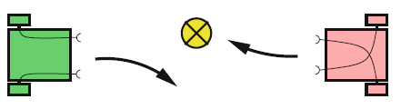

Figure 2.0 Two very simple Braitenberg vehicles and their reactions to a light source

So-called Braitenberg vehicles have two wheels, each of which is driven by an independent electric motor. The speed of each motor is influenced by a light sensor on the front of the vehicle as shown in Fig. 2.0. The more light that hits the sensor, the faster the motor runs. Vehicle 1 in the left part of the figure, according to its configuration, moves away from a point light source. Vehicle 2 on the other hand moves toward the light source. Further small modifications can create other behavior patterns, such that with these very simple vehicles we can realize the impressive behavior described above.

Clearly the above definition is insufficient because AI has the goal of solving difficult practical problems which are surely too demanding for the Braitenberg vehicle. In the Encyclopedia Britannica [Bri91] one finds a Definition that goes like:

**Definition 2.**

**“AI is the ability of digital computers or computer controlled robots to solve problems that are normally associated with the higher intellectual processing capabilities of humans …”**

But this definition also has weaknesses. It would admit for example that a computer with large memory that can save a long text and retrieve it on demand displays intelligent capabilities, for memorization of long texts can certainly be considered a higher intellectual processing capability of humans, as can for example the quick multiplication of two 20-digit numbers. According to this definition, then, every computer is an AI system. This dilemma is solved elegantlyby the following definition by Elaine Rich [Ric83]:

**Definition 3.**

**“Artificial Intelligence is the study of how to make computers do things at which, at the moment, people are better.”**

Rich, tersely and concisely, characterizes what AI researchers have been doing for the last 50 years. Even in the year 2050, this definition will be up to date.

Tasks such as the execution of many computations in a short amount of time are the strong points of digital computers. In this regard they outperform humans by many multiples. In many other areas, however, humans are far superior to machines. For instance, a person entering an unfamiliar room will recognize the surroundings within fractions of a second and, if necessary, just as swiftly make decisions and plan actions. To date, this task is too demanding for autonomous robots. According to Rich’s definition, this is therefore a task for AI. In fact, research on autonomous robots is an important, current theme in AI. Construction of chess computers, on the other hand, has lost relevance because they already play at or above the level of grandmasters.

It would be dangerous, however, to conclude from Rich’s definition that AI is only concerned with the pragmatic implementation of intelligent processes. Intelligent systems, in the sense of Rich’s definition, cannot be built without a deep understanding of human reasoning and intelligent action in general, because of which neuroscience is of great importance to AI. This also shows that the other cited definitions reflect important aspects of AI

Figure 2.1 Solutions offered by Artificial Intelligence

**2.3 Machine Learning**

Machine Learning is a branch of Artificial Intelligence and can be defined as a form of applied statistics with increased emphasis on the use of computers to statistically estimate complicated functions and a decreased emphasis on proving confidence on those functions.

**2.31**. **What is learning?**

According to Mitchelle (1997)’s description of learning, “A machine or computer is said to learn from experience E with respect to some class of tasks T and performance measure P if and only if its performance on T as measured by P improves with experience in E”

Machine learning has three main categories:

1. **Supervised Learning**. The aim of supervised learning is to build a model that makes predictions based on evidence in the presence of uncertainty. A supervised learning algorithm takes a known set of input data and known response to the data (output) and trains a model to generate reasonable predictions for the response to new unobserved data.
2. **Unsupervised Learning**. Unsupervised learning finds hidden patterns or intrinsic structures in data. It is used to draw inferences from datasets consisting of input data without labelled responses.
3. **Hybrid Learning.** A combination of both supervised and unsupervised learning techniques and algorithms.

However, in the project’s implementation, I emphasized on supervised learning that approximates a target function, (f) that maps input variables (x) to an output variable (y), i.e.

y = f(x)

In this case, the inputs are 1332 images of the maize leaves while the expected outputs are the four maize disease classes and a class of healthy leaves as mentioned in part 1.1 above.

**2.4 Neural Networks**

Artificial neural networks are popular machine learning techniques that simulate the mechanismof learning in biological organisms. The human nervous system contains cells, whichare referred to as *neurons*. The neurons are connected to one another with the use of *axons*and *dendrites*, and the connecting regions between axons and dendrites are referred toas *synapses*. These connections are illustrated in Figure 2.41(a). The strengths of synapticconnections often change in response to external stimuli. This change is ho learning takesplace in living organisms.

This biological mechanism is simulated in *artificial* neural networks, which contain computation units that are referred to as neurons. Throughout this book, we will use the term “neural networks” to refer to artificial neural networks rather than biological ones. The computational units are connected to one another through weights, which serve the same role as the strengths of synaptic connections in biological organisms. Each input to a neuron is scaled with a weight, which affects the function computed at that unit. This architecture is illustrated in Figure 2.41(b). An artificial neural network computes a function of the inputs by propagating the computed values from the input neurons to the output neuron(s) and using the weights as intermediate parameters.



Figure 2.41(a) Biological Neural Network



Figure 2.41(b) Artificial Neural network (perceptron)

Learning occurs by changing the weights connecting the neurons. Just as external stimuli are needed for learning in biological organisms, the external stimulus in artificial neural networks is provided by the training data containing examples of input-output pairs of the function to be learned. For example, the training data might contain pixel representations of images (input) and their annotated labels (e.g., carrot, banana) as the output. These training data pairs are fed into the neural network by using the input representations to make predictions about the output labels.

The training data provides feedback to the correctness of the weights in the neural network depending on how well the predicted output (e.g., probability of a type of disease in maize) for a particular input matches the annotated output label in the training data.

One can view the errors made by the neural network in the computation of a function as a kind of unpleasant feedback in a biological organism, leading to an adjustment in the synaptic strengths.

Similarly, the weights between neurons are adjusted in a neural network in response to prediction errors. The goal of changing the weights is to modify the computed function to make the predictions more correct in future iterations. Therefore, the weights are changed carefully in a mathematically justified way so as to reduce the error in computation on that example. By successively adjusting the weights between neurons over many input-output pairs, the function computed by the neural network is refined over time so that it provides more accurate predictions. Therefore, if the neural network is trained with many different images of maize leaves, it will eventually be able to properly recognize a maize disease in an image it has not seen before.

This ability to accurately compute functions of unseen inputs by training over a finite set of input-output pairs is referred to as ***model generalization*.** The primary usefulness of all machine learning models is gained from their ability to generalize their learning from seen training data to unseen examples.

The biological comparison is often criticized as a very poor caricature of the workings of the human brain; nevertheless, the principles of neuroscience have often been useful in designing neural network architectures. A different view is that neural networks are built as higher-level abstractions of the classical models that are commonly used in machine learning. In fact, the most basic units of computation in the neural network are inspired by traditional machine learning algorithms like ***least-squares regression***and ***logistic regression*.**

Neural networks gain their power by putting together many such basic units, and learning the weights of the different units jointly in order to minimize the prediction error. From this point of view, a neural network can be viewed as a ***computational graph***of elementary units in which greater power is gained by connecting them in particular ways. When a neural network is used in its most basic form, without hooking together multiple units, the learning algorithms often reduce to classical machine learning models. The real power of a neural model over classical methods is unleashed when these elementary computational units are combined, and the weights of the elementary models are trained using their dependencies on one another. By combining multiple units, one is increasing the power of the model to learn more complicated functions of the data than are inherent in the elementary models of basic machine learning. The way in which these units are combined also plays a role in the power of the architecture, and requires some understanding an insight from the analyst. Furthermore, sufficient training data is also required in order to learn the larger number of weights in these expanded computational graphs.

**Neural Network Architecture**

This simple instantiation of a neural network is also referred to as the ***perceptron*.**

In multi-layer neural networks, the neurons are arranged in layered fashion, in which the input and output layers are separated by a group of hidden layers. This layer-wisearchitecture of the neural network is also referred to as a ***feed-forward network*.**

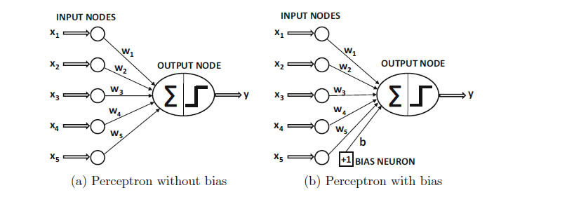

Figure 2.42. Architecture of a simple neural network

**2.41. Convolutional Neural Networks.**

The regular NN (neural network) is not equipped for managing the images. If a regular NN were to be used with the images, then each pixel of the image would have to be connected to its neuron resulting in a network which would be computationally expensive. CNN handles the images in various ways, yet, at the same time, it pursues the general idea of regular NN. Figure 2.43 shows the architecture of the CNN used.



Figure 2.43. CNN architecture

Convolution and pooling (feature extraction): Convolution has a set of learnable filters which are a matrix (width (W), height (H), and depth (D)). The input image is considered as a matrix and the filter is imagined sliding through the input image matrix in order to get the convoluted image which is the filtered image of the actual input image. If a filter is applied on the input image, the result would be an output matrix smaller than the original image. Padding plays an important role if we need to get the same size outputted as the input size. Pooling is another important concept of CNN. Pooling is a form of non-linear down sampling function that in the case of CNNs is applied to convoluted images. Among several non-linear functions that can do the pooling, max pooling is the most common one.

**2.5 Related Work**

The use of machine learning algorithms for the detection of plant leaf disease is dominant in theliterature. Machine learning models for the prediction of these plant leaf diseases were found to differin accuracy. Various techniques are at present being used for the recognition of plant leaf diseasesby the application of computer vision. One of them is disease detection by colour feature extractionfrom images. CNNs are known to outsmart the classification and identification of images by use of a colour feature extraction. For such reasons, Sladojevic et al. performed the deep CNN training forplant disease recognition and classification. The test results on the created model accomplishedaccuracy somewhere in the range of 91% and 98%, for separate class tests, 96.3% on average

Utilizing an open dataset of 54,306 images of diseased and healthy plant leaves gathered under controlled conditions, Mohanty et al. trained a deep CNN to distinguish 14 crop species and 26 diseases The trained model accomplished a precision of 99.35% on a held-out test set, showing the plausibility of this approach.

A study in comparison of support vector machine (SVM) and ANN, was performed by Pujai et al. Algorithms for colour extraction and texture features were developed, which were thus used to train SVM and ANN classifiers. The study presented a reduced feature set based approach for the recognition and classification of images of plant diseases. The results revealed that the SVM classifier was progressively reasonable for identification and classification of plant diseases. An SVM classifier was 92.17% than the ANN classifier that had an accuracy of 87.4%

Recently, wheat disease detection through leaf image and data processing techniques is used extensively to assist farmers in monitoring the big plantation area. Researchers such as Dixit and Ema applied SVM for the recognition and classification of wheat diseases. In their study, they mentioned in detail the key issues and challenges in wheat leaf detection by means of SVM.

The purpose of this project however, is to model a deep convolutional neural network and extend the inference part of the model to an android device. The test accuracies of the tested images can be as depictected below.

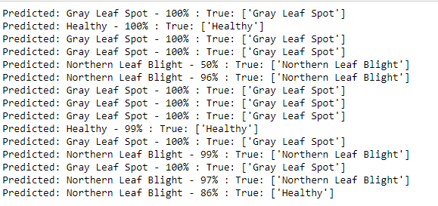

# 3. CHAPTER THREE: METHODOLODY

**3.1 Introduction**

This chapter describes the various requirements in terms of software, hardware, functional and non-functional requirements, and the target users of the application, the population sampling technique used in the data chosen for the study.

**3.2 Target Users**

The targeted users of this application are mainly maize farmers either small-scale or large-scale farmers or other parties as highlighted in part 1.8 of this document under the beneficiaries.

**3.3 Target Population**

In terms of the dataset used in the study, the application to its final implementation is expected to be used by a wider variety of users across the East African divide and most importantly by maize farmers.

**3.4 Sample population and how it was arrived at**

The training and validation datasets were split using the percentage split technique of data division into 80% training and 20% validation.

**3.5 Methodologies of data collection**

* 1. The image dataset was typically downloaded from the PlantVillage.
  2. Observation trough online research.

**3.6 System Requirements**

**3.61 Hardware Requirements**

1. An android smart phone with a clear camera
2. Maize Leaves Dataset.
3. A laptop of at least 280GB of RAM

**3.62 Software Requirements**

1. Python 2.7 or Python 3 installed on the machine in 3.6.1.3 above
2. Anaconda Tool (Version three or higher) that comes with additional python development tools including Jupyter Notebook.
3. Java Standard Development Kit 7 and above
4. Java Virtual Machine (JVM)
5. Android Studio IDE
6. Ubuntu 16 or higher

**3.63 Functional Requirements**

1. Maize Disease Identification
2. Maize Disease Classification
3. Feature extraction from the maize leaves
4. Maize disease diagnosis

**3.64 Non Functional Requirements.**

1. Performance of the model and the android system
2. Reliability of the model
3. Security of the user data
4. Scalability of the android software to allow more users
5. Efficiency of the model during inference on the android device.

**3.7 Software development methodologies**

**3.7.1 Introduction**

This part proved an overview of the development methodologies of the two parts of the project including;

1. **Android System Development Methodology**

In the design of the android application, I have followed the Software Development Life Cycle as illustrated below:



Figure 3.1. Software Development Life Cycle Diagram

1. **Communication**

At this stage, I initiated the project by defending the proposal in my third year of study to develop the model in the first phase of the project, one that could be able to classify the different maize diseases. The proposal was accepted and I was given the go ahead to implement the first phase. However, during the project defense in early January, I also stated that in the second phase of the project’s implementation, I would wish to develop an android device and ship the model developed in the first phase to be able to enable farmers perform diagnosis of their maize crops using their smart phone’s cameras

1. **Requirements Gathering.**

**Introduction**

This step onwards the software development team works to carry on the project. The team holds discussions with various stakeholders from problem domain and tries to bring out as much information as possible on their requirements. The requirements are contemplated and segregated into user requirements, system requirements and functional requirements.

In the case of this project and study, I began on a study to observe if there are any existing systems that offer the solution to maize disease classification and consequent diagnosis using an android device that a is accessible and affordable to the majority of the maize farmers.

Here, I found out that in the wider parts of India, there exists an application that focuses on a wide variety of crops including beans, cassavas, carrots, bananas and etc. Which is therefore why I had to zero-in on maize and particularly with a focus on maize farming in Kenya and the wider East African Community.

The major technique involved in this stage of the software development life cycle is observation through online research.

1. **Feasibility Study**

**Introduction**

After requirement gathering, the team comes up with a rough plan of software process. At this step the team analyzes if a software can be designed to fulfill all requirements of the user, and if there is any possibility of software being no more useful. It is also analyzed if the project is financially, practically, and technologically feasible for the organization to take up. There are many algorithms available, which help the developers to conclude the feasibility of a software project.

In my case, I assessed the viability of the project in terms of cost, time schedule and the accessibility and availability of the requirements obtained in part (b) above and deemed it feet to go ahead with the execution of the idea since there were not much challenges of accessing the data and information and at the same time, being that I purposed to develop the project using my own machine, it was not going to bare much expensive costs.

1. **System Analysis**

**Introduction.**

At this step the developers decide a roadmap of their plan and try to bring up the best software model suitable for the project. System analysis includes understanding of software product limitations, learning system related problems or changes to be done in existing systems beforehand, identifying and addressing the impact of project on organization and personnel etc. The project team analyzes the scope of the project and plans the schedule and resources accordingly.

Relating this step to my project and study, I was able to come up with the necessary gatherings in terms of the above described aspects as can be seen in the first chapter of this document.

1. **System Design**

The design is as described in part 4.1.2 of this document.

1. **Coding**

The idea has been implemented using the java language and the Tensorflow lite API that acts as an interface to machine learning in mobile, IOS and microcontroller devices, a concept best known as **on-device machine learning.**

The code to the project can be found on the Github version control tool at <https://github.com/Dickens-odera/Maize-Disease-Andorid-Classification>

With a bit of borrowed concepts from the Tensorflow Android development team at <https://tensorflow.org>

1. **Testing**

The application is tested and running both on an android emulator provided by Android Studio and on a hand-held smart phone with effective camera capabilities.

1. **Implementation**

This means installing the software on user machines. At times, software needs post-installation configurations at user end. Software is tested for portability and adaptability and integration related issues are solved during implementation.

Below are some of the screenshots to the application taken during the installation on my android devise:

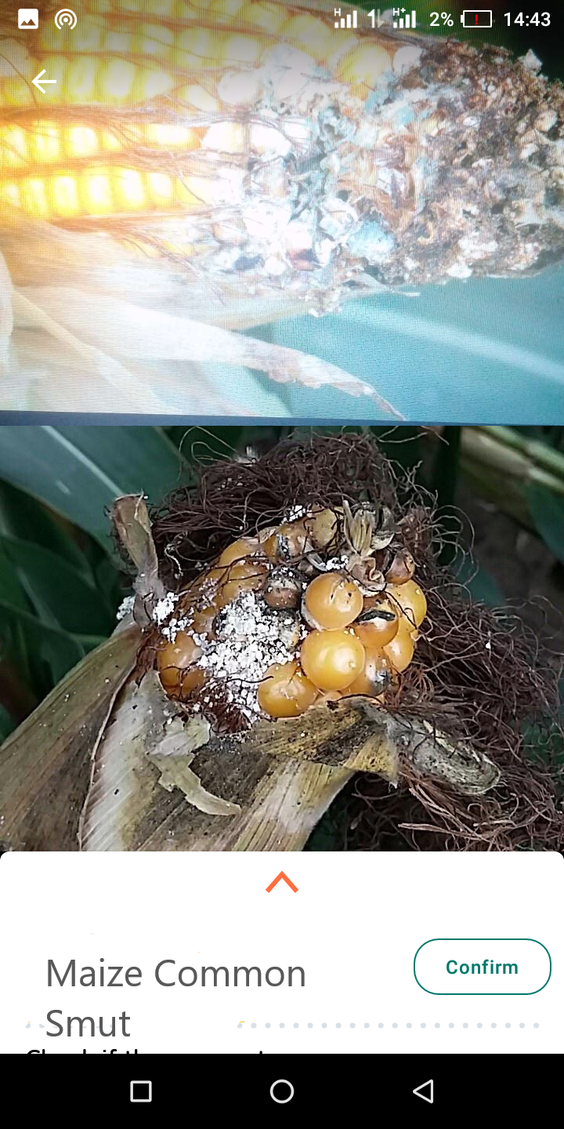

Figure 3.2. A screenshot of the android Camera User Interface with maize common smut disease on an affected maize leaf

1. **Operation and Maintenance**

At this stage, I intend to make additional changes to the application while checking on possible errors with a focus on efficiency before release to the general public.

**The Iterative Model Paradigm**

In terms of the software development paradigm used, I deemed it fit to use the iterative model of software development by developing simple modules such as the Camera 2 API and the inference module and the integrating them to the already developed modules.

Below is preview of the iterative model.



Figure 3.3. The Iterative model.

1. **Model Development Methodology**

The model was developed using the high level Keras Sequential API and Tensorflow machine learning framework provided by Google.

In the development of the model, Tensorflow lite is used to optimize the model to a format that is able to run on mobile.

The two main components of Tensorflow lite used in the developing the model include:

1. The [Tensorflow Lite interpreter](https://www.tensorflow.org/lite/guide/inference), which runs specially optimized models on many different hardware types, including mobile phones, embedded Linux devices, and microcontrollers.
2. The [Tensorflow Lite converter](https://www.tensorflow.org/lite/convert/index), which converts Tensorflow models into an efficient form for use by the interpreter, and can introduce optimizations to improve binary size and performance.

Tensorflow Lite is designed to make it easy to perform machine learning on devices, "at the edge" of the network, instead of sending data back and forth from a server. For developers, performing machine learning on-device can help improve:

1. **Latency.** there's no round-trip to a server
2. **Privacy**. no data needs to leave the device
3. **Connectivity.** an Internet connection isn't required
4. **Power Consumption**. network connections are power hungry

**About Tensorflow.**

Tensorflow as a machine learning framework developed and maintained by Google, it is an end-to-end platform that makes it easy to build and deploy machine learning models.

It offers an entire ecosystem that helps in solving challenging real-world machine learning problems.

Tensorflow is one of the widely used libraries for implementing Machine learning and other algorithms involving large number of mathematical operations.

**About Keras.**

Keras is an API designed for human beings, not machines. Keras follows best practices for reducing cognitive load: it offers consistent & simple APIs, it minimizes the number of user actions required for common use cases, and it provides clear & actionable error messages. It also has extensive documentation and developer guides.

The final solution of the model’s development can be found at

<https://github.com/Dickens-odera/MAIZE-DISEASE-CLASSIFIER-2020> on Github.

# 4. CHAPTER FOUR: SYSTEM DESIGN

**4.1 Introduction**

This chapter covers the two stages involved in the development of the machine learning model and the android application as outlined below:

1. Dataset Design
2. Android System Design

**4.1.1 Dataset Design**

Here, three separate datasets arerequired to develop the classification model. The first set, the training set,is the collection of images to be used by the network toautomatically learn its hidden parameters, such as weights andbiases. The second set, the validation set, is used to manuallyadjust hyperparameters, which are essentially the settings thatcannot be automatically learned during training. These includeamong others the learning rate, the batch size and the networkarchitecture.

CONTINUE

**4.1.2 Android System Design**

.

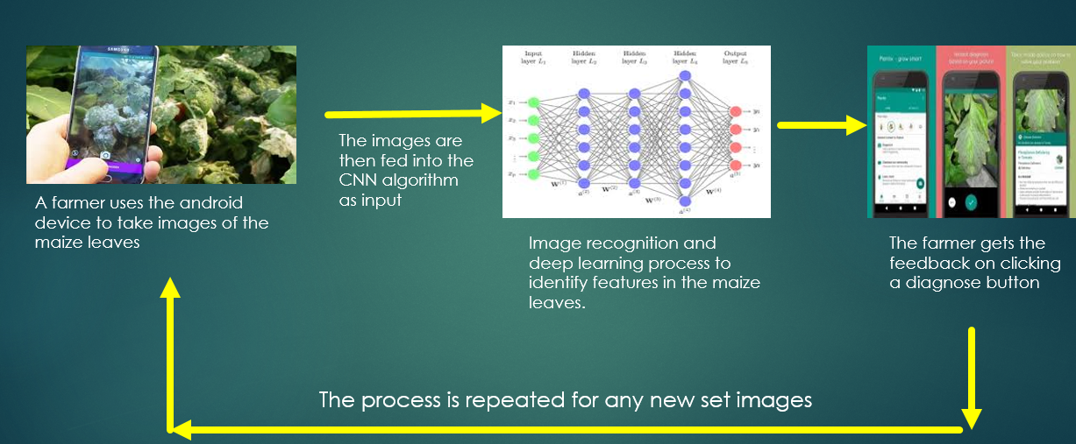

Figure 4.1. A pictorial View of the Data Flow Diagram of the functionality of the android application for this purpose

.

# 5.0 CHAPTER FIVE: SYSTEM IMPLEMENTATION

**5.1 Introduction**

This particular study was conducted in 2 sections. i.e.

**5.1.1 Classification with Python, Tensorflow and Keras**

This part covers the processes of loading the required python software libraries, statistical and data visualization libraries, Tensorflow and Keras frameworks, loading the datasets (maize leaf images) from the operating system, image pre-processing, building of the model, training and finally performing test on unobserved image input..

1. **Loading Tensorflow and Keras API** that gives a wide range of high level functions, methods and classes to work with the data during building of the model, training and testing of the created model.

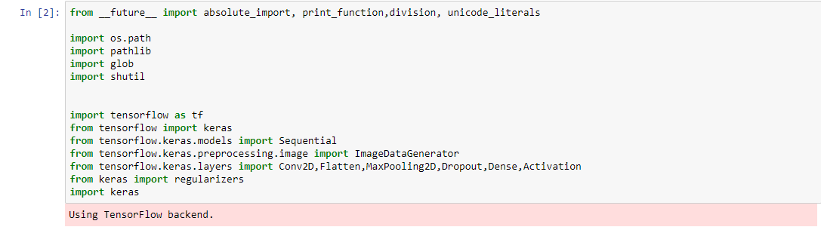

1. **Load Matplotlib and Numpy python data manipulation and visualization libraries** respectively to help in plotting the trained model’s graphs e.g accuracy, loss and histograms for effective visualization of its performance.

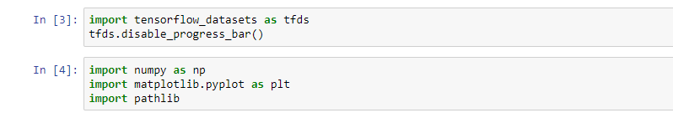

1. **Load dataset and declare the batch size for each iteration during training**, also, declare the classes of the images in the dataset for classification.

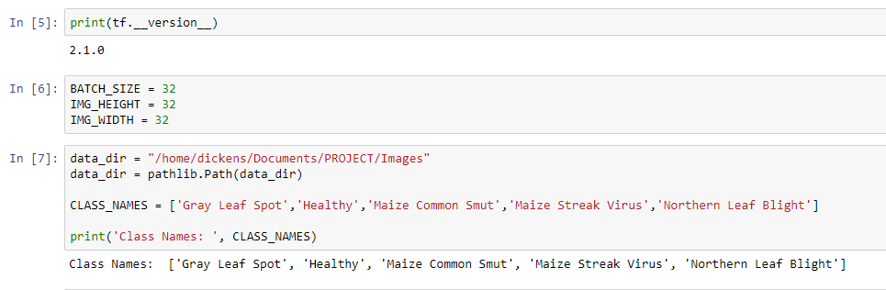

1. **Using percentage split (Holdout Strategy)**, group the dataset into 80% training and 20% validation sets

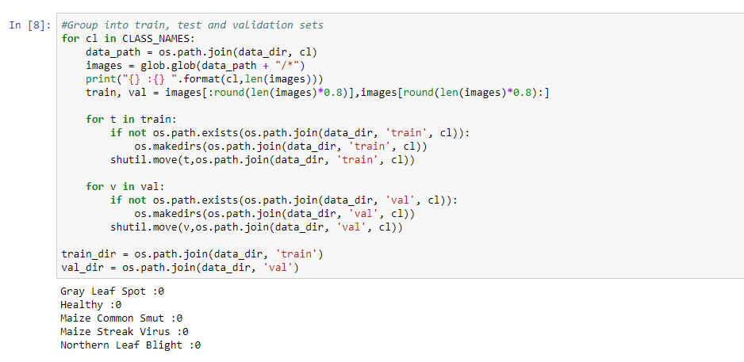

1. **Data Pre-processing and augmentation.**

Before sending images to the network, two pre-processing steps are often necessary. First, the images must typically be resized to match the size of the input layer of the CNN.

Secondly, the images must be normalized to help the model to converge more quickly as well as to better generalize on unseen data.

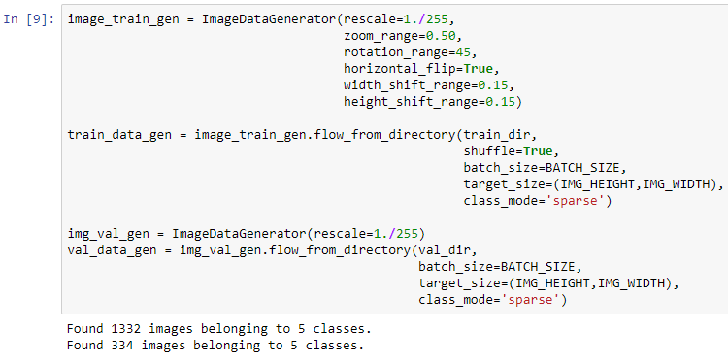

1. **Plot a few training and validation images** using Matplotlib

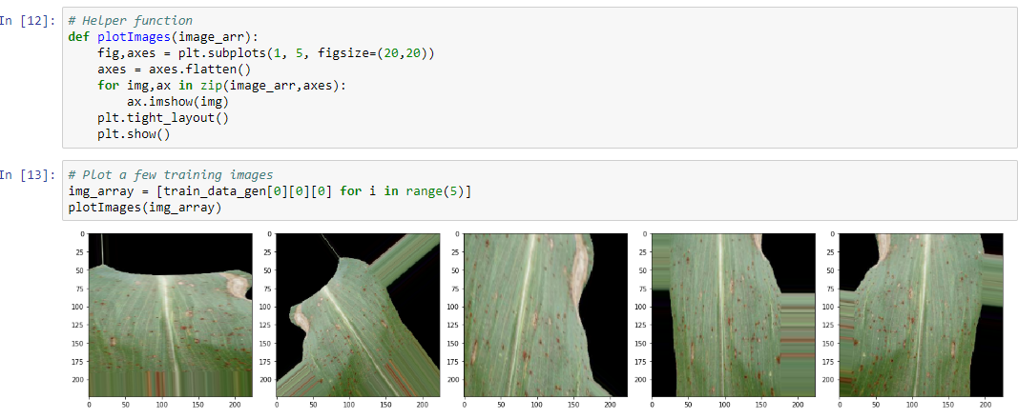

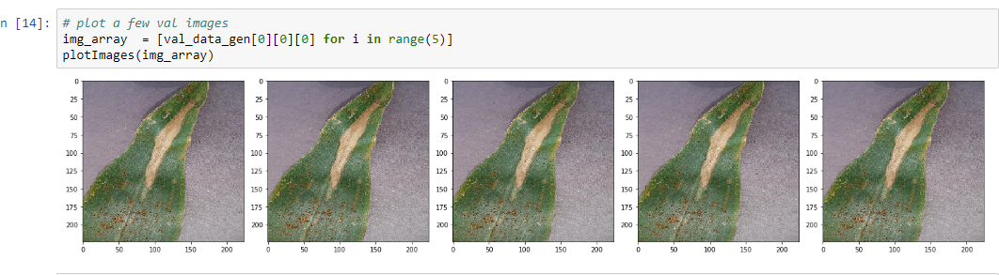

1. **Building of the model**

The major steps involved in building of the model include:

1. Convolution.
2. Feature Learning. At this step, the model learns features in input image through convolution. Introduce non-linearity through activation functions. In this case, the ReLu activation function was used.
3. Class Probabilities.

**Activation Functions.**

**Introduction.**

Activation functions are central to deep learning architectures. They determine

The output of the model, its computational efficiency, and its ability to train and converge after multiple iterations of training.

*An activation function is a mathematical equation that determines the output of each element (perceptron or neuron) in the neural network*.

It takes in the input from each neuron and transforms it into an output, usually between one and zero or between -1 and one. Classic activation functions used in neural networks include the step function (which has a binary input), sigmoid and ***tanh.*** New activation functions, intended to improve computational efficiency, include ***ReLu*** and Swish.

In a neural network, inputs, which are typically real values, are fed into the neurons in the network. Each neuron has a weight, and the inputs are multiplied by the weight and fed into the activation function.

Each neurons output is the input of the neurons in the next layer of the network, and so the inputs cascade through multiple activation functions until eventually, the output layer generates a prediction. Neural networks rely on nonlinear activation functions, the derivative of the activation function helps the network learn through the ***backpropagation*** process.

Three (3) types of activation functions used are:

1. **Binary step function**.

A binary step function is a threshold-based activation function. If the input value is above or below a certain threshold, the neuron is activated and sends exactly the same signal to the next layer. The problem with a step function is that it does not allow multi-value outputs for example, it cannot support classifying the inputs into one of several categories.

1. **Linear activation function.** Takes the form y = ax

It takes the inputs, multiplied by the weights for each neuron, and creates an output signal proportional to the input. In one sense, a linear function is better than a step function because it allowsmultiple outputs, not just yes and no.

However, a linear activation function has two major problems:

1. Not possible to use backpropagation (gradient descent) to train the model the derivative of the function is a constant, and has no relation to the input, X. So it’s not possible to go back and understand which weights in the input neurons can provide a better prediction.
2. All layers of the neural network collapse into one with linear activation functions, no matter how many layers in the neural network, the last layer will be a linear function of the last layer (because a linear combination of linear functions is still a linear function). So a linear activation function turns the neural network into just one layer.

A neural network with a linear activation function is simply a linear regression model. It has limited power and ability to handle complexity varying parameters of input data.

1. **Non-Linear Activation Functions.**

Modern neural network models use non-linear activation functions. They allow the model to create complex mappings between the networks inputs and outputs which are essential for learning and modeling complex data, such as images, video, audio, and datasets which are non-linear or have high dimensionality.

Almost any process imaginable can be represented as a functional computation in a neural network, provided that the activation function is non-linear.

Non-linear functions address the problems of a linear activation function:

1. They allow backpropagation because they have a derivative function which is related to the inputs.
2. They allow stacking of multiple layers of neurons to create a deep neural network. Multiple hidden layers of neurons are needed to learn complex data sets with high levels of accuracy.

Common activation functions used in machine learning are as described below:

1. **Sigmoid Activation Function.**

The logistic sigmoid function has a smooth gradient and outputs values between zero and one. For very high or low values of the input parameters, the network can be very slow to reach a prediction, called the vanishing gradient problem.



**Advantages:**

1. Smooth gradient - prevents "jumps" in the output values
2. Output values bound between 0 and 1, normalizing the output of each neuron.
3. Clear predictions - For x > 2 or x < 􀀀2, tends to bring Y value (the prediction) to the edge of the curve, very close to 1 or 0. This enables clear predictions.

**Disadvantages:**

1. Vanishing gradient for very high or very low values of X, there is almost no change to the prediction, causing a vanishing gradient problem. This can result in the network refusing to learn further,or being too slow to reach an accurate prediction.
2. Outputs not zero centered.
3. Computationally expensive.
4. **The TanH function** is zero-centered making it easier to model inputs that are strongly negative strongly positive or neutral.



**Advantages.**

1. Zero centered making it easier to model inputs that have strongly negative, neutral, and strongly positive values.
2. Otherwise like the Sigmoid function.

**Disadvantages.**

1. Like the ones of logistic sigmoid function
2. **The ReLu.** Function is highly computationally efficient but is not able to process inputs that approach zero or negative.



**Advantages**

1. Computationally efficient allows the network to converge very quickly.
2. Non-linear though it looks like a linear function, ReLU has a derivative function and allows forbackpropagation

**Disadvantage.**

The Dying ReLU problem when inputs approach zero, or are negative, the gradient of the function becomes zero, and the network cannot perform backpropagation and cannot learn.

1. **The Leaky ReLu function** has a small positive slope in its negative area, enabling it to process zero or negative values.



**Advantages.**

1. Prevents dying ReLU problem this variation of ReLU has a small positive slope in the negative area, so it does enable backpropagation, even for negative input values
2. Otherwise like ReLU

**Disadvantages.**

1. Results not consistent leaky ReLU does not provide consistent predictions for negative inputvalues.
2. **The Parametric ReLu** function allows the negative slope to be learned, performing backpropagationto learn the most effective slope for zero and negative input values



**Advantages.**

1. Allows the negative slope to be learned unlike leaky ReLU, this function provides the slope of the negative part of the function as an argument. It is, therefore, possible to perform backpropagationand learn the most appropriate value of.
2. Otherwise like ReLU

**Disadvantage.**

1. May perform differently for different problems.
2. **Softmax Activation Function** is a special activation function use for output neurons. It normalizes outputs for each classbetween 0 and 1 and returns the probability that the input belongs to a specific class.

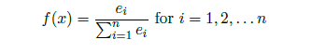

**Advantages.**

1. Able to handle multiple classes only one class in other activation functions normalizes the outputs for each class between 0 and 1, and divides by their sum, giving the probability of the input valuebeing in a specific class.
2. Useful for output neurons typically Softmax is used only for the output layer, for neural networksthat need to classify inputs into multiple categories.

**Conclusion.**

Because of the highlighted advantages of the Softmax activation function in relation to the other activation functions and taking into the consideration the nature of the idea whereby the problem at hand is a classification problem that expects outputs of either zero or one, I chose the Softmax activation function for the output neuron.

Also, as can be seen in the below image, the ReLu activation function is used during building of the model.

Convolution layers serve the purpose of producing convolved feature maps.

Convolution provides a way of `multiplying together' two arrays of numbers, generally of different sizes, but of the same dimensionality, to produce a third array of numbers of the same dimensionality. This can be used in image processing to implement operators whose output pixel values are simple linear combinations of certain input pixel values.

In an image processing context, one of the input arrays is normally just a graylevel image. The second array is usually much smaller, and is also two-dimensional (although it may be just a single pixel thick), and is known as the [kernel](https://homepages.inf.ed.ac.uk/rbf/HIPR2/kernel.htm). The figure shows an example image and kernel that we will use to illustrate convolution.

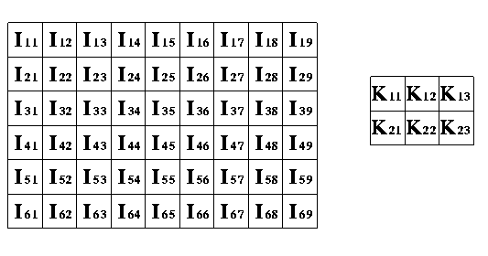

Figure 5.0 Convolution that produces a much reduced array of the pixels.

The basic steps involved in building the model include:

1. Learning features in input image through convolution.
2. The ReLu activation function introduce non-linearity as the real world data (images) is non-linear.
3. The pooling layer perform dimensionality reduction and preserve spatial-invariance. This results in downsampling that also makes processing much faster.

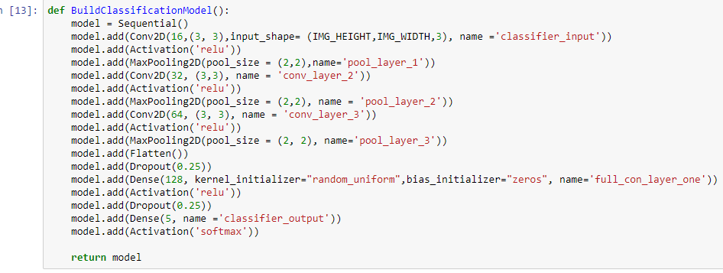

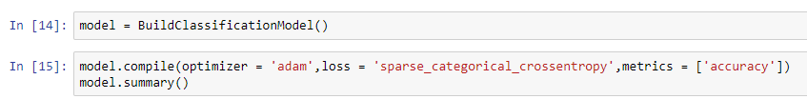

A summary of the model can be observed as bellow.

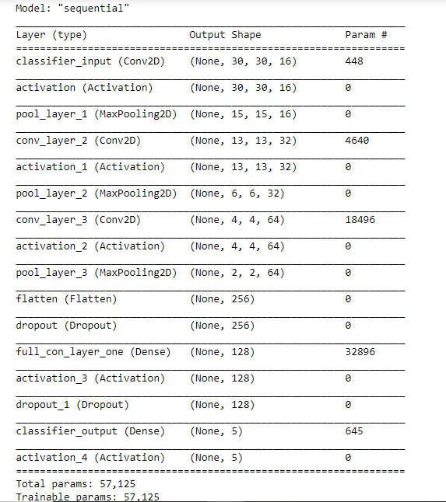

1. **Model Training.**

During the training phase, the model’s internal weights areautomatically updated over 50 iterations. External factorssuch as the training strategy, architecture, regularizationtechniques, or the value of the hyperparameters influence thistraining process.

**Training Strategy.**

As opposed to **transfer learning** which uses already pre-trained models and fine-tuning them to fit the task in question**,** the above model was trained from scratch using the multi-layered deep neural network.

In the training process, the parameters applied to the “***fit_genetor****”* model include the number of training iterations in this case called the epochs, the training dataset and validation dataset.

For the purpose of tracking the model’s performance during training, an additional parameter known as the callback is necessary to save the model’s checkpoints by declaration log directory for the saving the checkpoints during training.

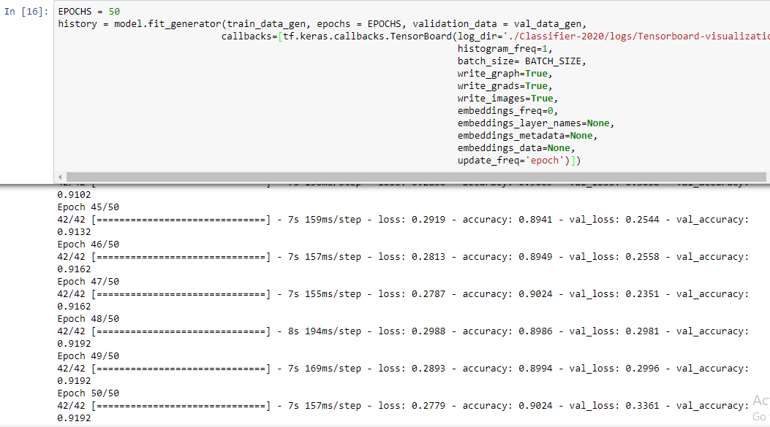

As it can be seen above, after 50 EPOCHS or iterations of training, the model achieved an accuracy of 90.24%.

The reason for the high number of iteration is to improve the model’s accuracy and performance on unobserved data during generalization.

1. **Model Performance Evaluation and Visualization.**

At this stage, the focus is to visualize the model’s training process and the graphs produced.

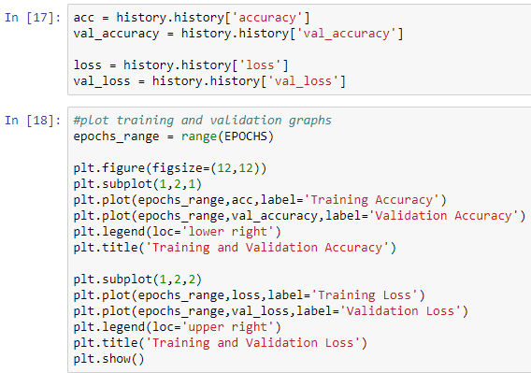

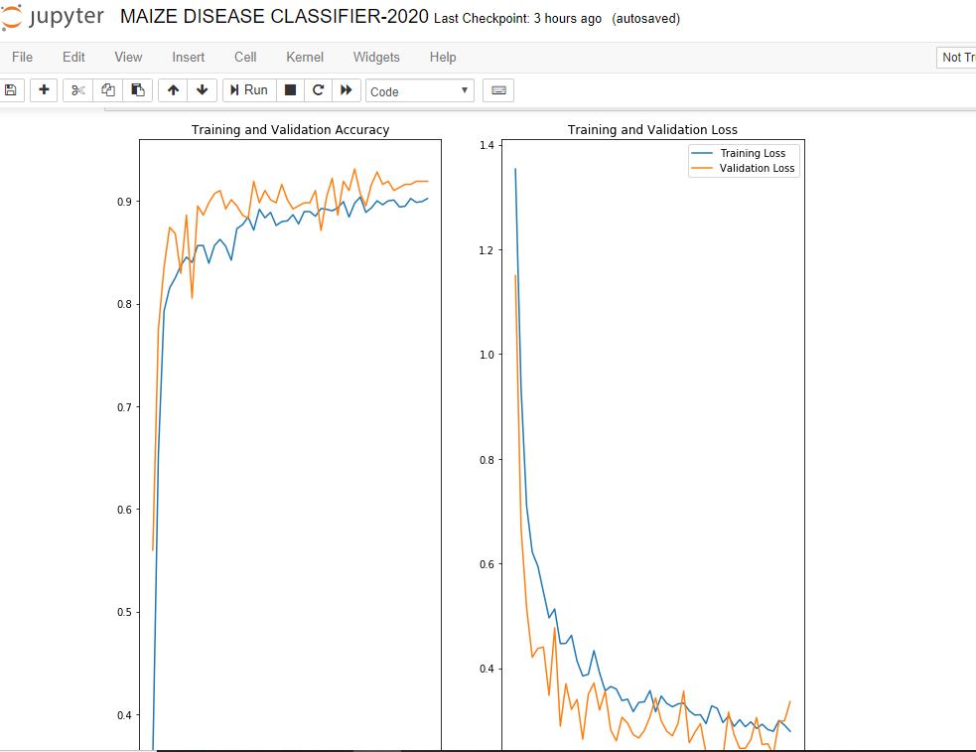

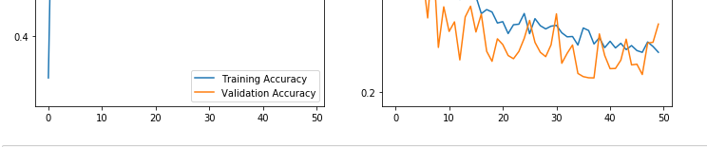

1. **Saving the model.**

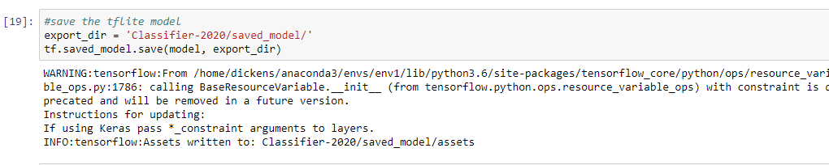

1. **Model Optimization for android using tflite**

At this stage, the tflite Optimizer and Converter APIs are used to optimize and convert the model for android inference into a .tflite mode.

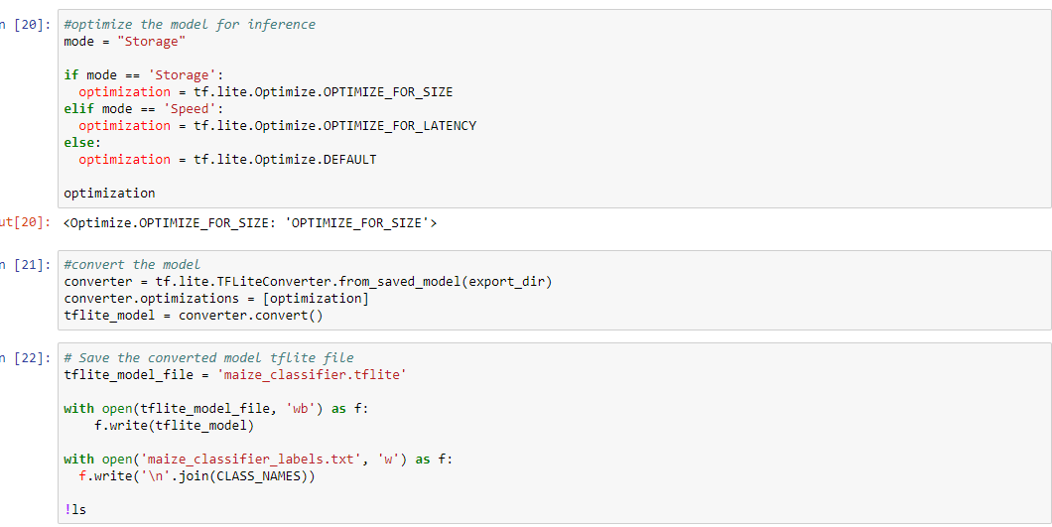

1. **Model Testing**

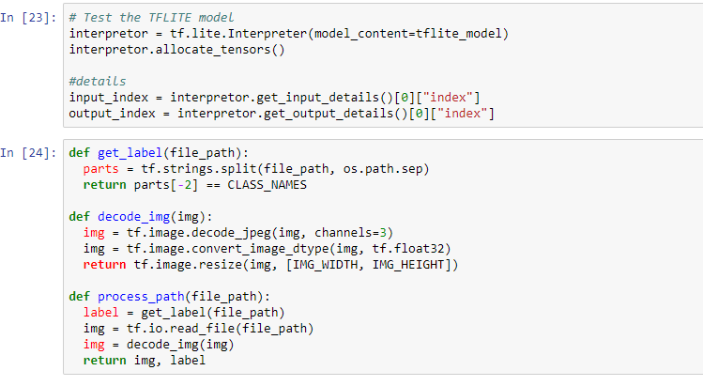

Upon testing the model, the following accuracies are obtained from the 15 images chosen for the test.

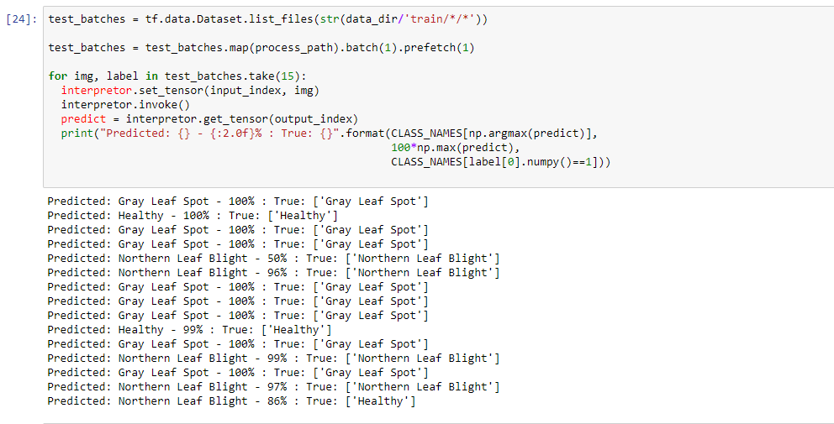

**5.1.3 Inference Performance on an Android Device (Testing of the model on android)**

The implementation and code to the android bit of the project can be found at

<https://github.com/Dickens-odera/Maize-Disease-Andorid-Classification> on Github as a public repository.

# 6. CHAPTER SIX: DISCUSSION

**6.1 Introduction**

The project right from its inception has proved that deep neural networks can be used to solve complex classification problems.

# 7. CHAPTER SEVEN: SUMMARY, CONCLUSIONS AND RECOMMENDATIONS

**Summary**

The model having gained and accuracy of 90%, it can perform better on the android device as the aspect of overfitting was addressed by the dropout layer during the building of the ML model.

**Conclusions**

1. CNNs can be used to perform classifications tasks.
2. Deeplearning as a domain of Machine Learning has a wide variety of applications.
3. Deep Convolutional Neural networks can be used in feature extraction to identify complex patterns within a set of data

**Recommendations.**

Use of more images and increasing the number of iterations during training in order t

# 8. REFERENCES

1. Wolgang Ertel. Introduction to Artificial Intelligence. Undergraduate Topics. Second Edition. Pages 1-3
2. Charu C. Aggarwal. Neural Networks and Deep Learning.
3. Laura Igual and Santi Segui. Introduction To Data Science. (A python Approach to Concepts, Techniques and Applications).
4. Steven S. Skiena. The Data Science Design Manual.
5. Kent D. Lee and Steve Hubbard. Data Structures and Algorithms with python.
6. Massimiliano Bonamente. Statistical Analysis of Scientific Data. Second Edition.
7. Malusi Sibiya and mbuyu Sumbwanyambe. (School of Engineering, College of Science, Engineering and Technology, University of South Africa, Pretoria 0003, South Africa). A computational Procedure for the Recognition of Maize Leaf Diseases out of Healthy Leaves Using Convolutional Neural Networks.
8. <https://tensorflow.org>
9. <https://keras.io>
10. Introduction to machine learning lecture notes from Dr. Raphael Angulu (PhD), Department of Computer Science, School of Computing and Informatics, Masinde Muliro University of Science and Technology.
11. <https://towardsdatascience.com/a-beginner-introduction-to-tensorflow-part-1-6d139e038278>

# 9. APPENDICES

1. The budget is as show below:

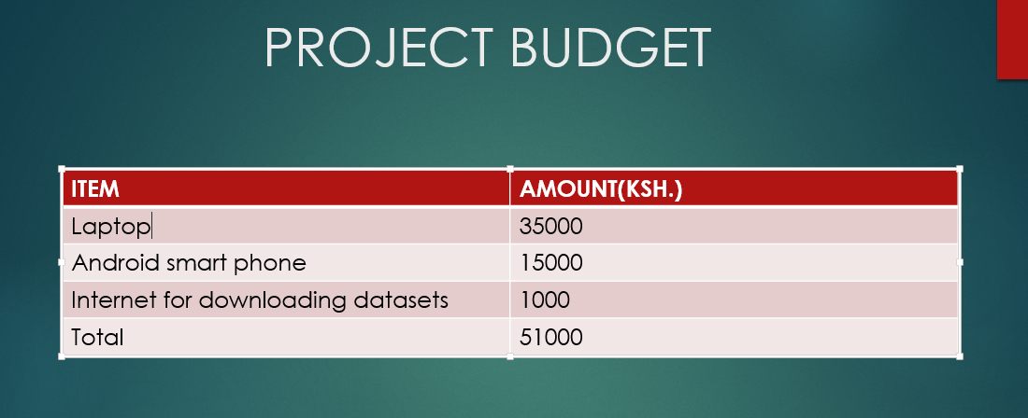

2. The CNN Algorithm

